الجمهورية اللبنانية
الاسم والشهرة:--------------------

رقم المرشح :----------------------
وزارة التربية والتعليم العالي الامتحانات الرسمية لشهادة الامتياز الفني
المديرية العامة للتعليم المهني والتقني لدورة عام 2016 الثانية
===============
الاختصاص والرمز : المعلوماتية الادارية ( 23104)
المادة : برمجة ويب Web المعدل: (10)
المستندات المسموح بها : لا شيء المدة : ساعتان

Treat the following questions : (5pts/question)
- Write the appropriate HTML5 and JAVASCRIPT tags to obtain as result the following page, that accept the user name and the password, while respecting the following conditions:
- "user" Entry Field must contain minimum 4 characters. The test should be done according to a function when we click outside the field.
- "password" Entry Field must contain minimum 5 characters. The test should be done according to a function when we click outside the field.
- "confirm password" Entry Field that must be identical to "password". The test should be done according to a function when we click outside the field.
- After a click on the button "login" all information must be sent to a page "login.html".
- The button "cancel" reset default values for all fields.

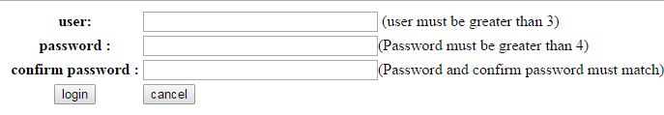

- Write the appropriate HTML5 tags and the appropriate CSS properties to obtain as result the following page:
- The page has the following properties:
  - Background color : gray(#dddddd).
- The first paragraph has the following properties:
  - Rounded borders : 20 pixels. Background color : white. Text aligned at the right.
Presentation : is a link towards the page : « presentation.html »
Sports is a link towards the web site : « fifa.com »
- The second paragraph has the following properties:
  - Rounded borders : 20 pixels. Background color : white. Text align at the left.
- The third paragraph has the following properties:
  - Border: 2 pixels Border style: « dashed » Text aligned at the center.

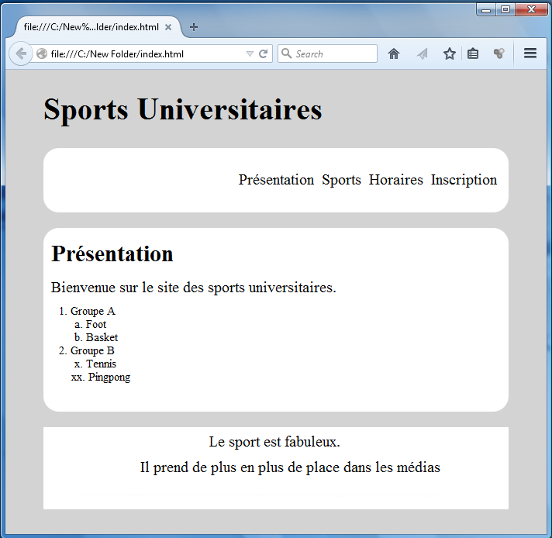
H1
P
P
P

الاختصاص والرمز : المعلوماتية الادارية ( 23104) المادة : برمجة ويب Web

- Write the appropriate HTML5 tags to obtain the following page :

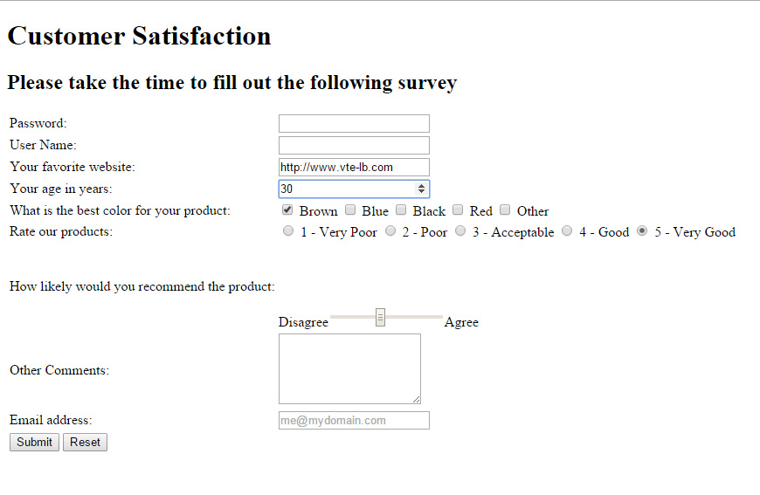

- Password: Input field "password", 40 visible characters and maximum 256 characters.
- User Name: Input field, 40 visible characters and maximum 256 characters.
- Indicate the appropriate type for each of the following fields: Web site, Email.
- Age: Input field "number" with default value 30, the biggest number that can be reached is 99.
- Color: Checkbox, many choices are acceptable.
- Rate our products: Radio button which only one choice is acceptable.
- Disagree/Agree: is a range between 1 and 10, the default value is 5.
- Other Comments: Input field, 3 rows and 40 characters.
- A button Submit to send data to: "www.mysite.com/select.php" using the post method.
- A button Reset to reset all values.

- Write the corresponding HTML5 tags and the appropriate CSS properties to obtain as result the following page:

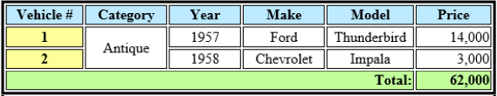

- The table has the following characteristics:
- - Width: 500 pixels - Height: 50 pixels - Space between borders: 2 pixels.
- The table border thickness is 5 pixels and the cells border thickness is 2 pixels.
- The background color of the first row is blue and for the last row is green.

